2018台北雙年展參展名單發佈
Taipei Biennial 2018 Announces Participating List

媒體圖說Image Description
下載高清圖片To download hi-res images: https://suttonpr.egnyte.com/fl/BQKCkrNmYo

- 2018 台北雙年展「後自然：美術館作為一個生態系統」主視覺  Taipei Biennial 2018, Post-Nature—A Museum as an Ecosystem | 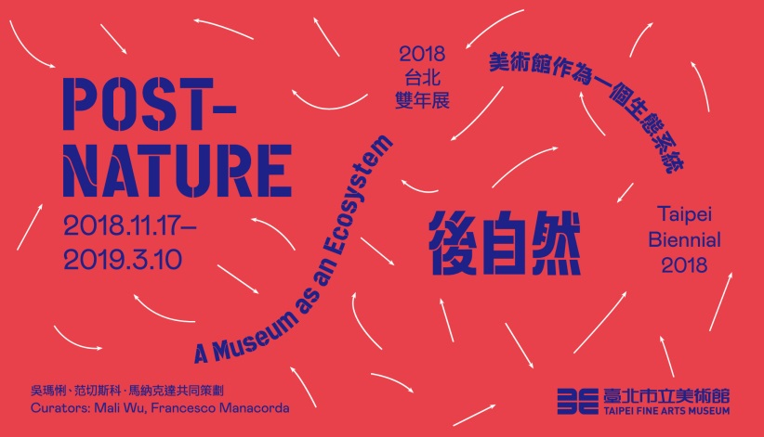
- 烏蘇拉．畢曼，《聲海》，2018。錄像裝置、科學儀器，19分鐘。影像由藝術家提供。  Ursula BIEMANN, Acoustic Ocean, 2018. Video Installation with scientific instruments, 19 mins. Courtesy of the artist. | 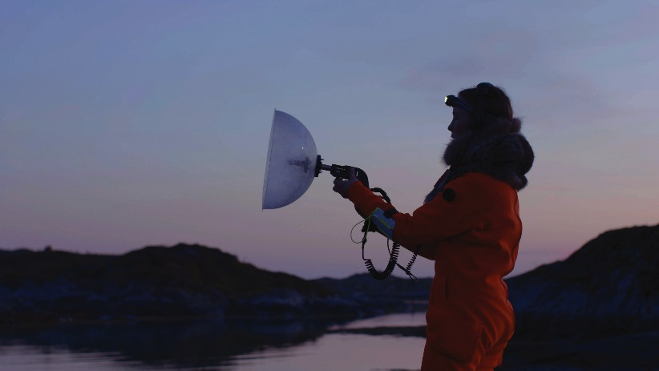
- 朱利安．夏利耶，《變質岩 XLIV》，2016。©藝術家與德國波昂 VG Bild-Kunst協會。傑森．維奇攝於紐約；影像由紐約尚凱利畫廊提供。  Julian Charrière, Metamorphism XLIV, 2016. ©Julian Charrière; VG Bild-Kunst, Bonn, Germany. Photo: Jason Wyche, New York. Courtesy of Sean Kelly Gallery, New York. | 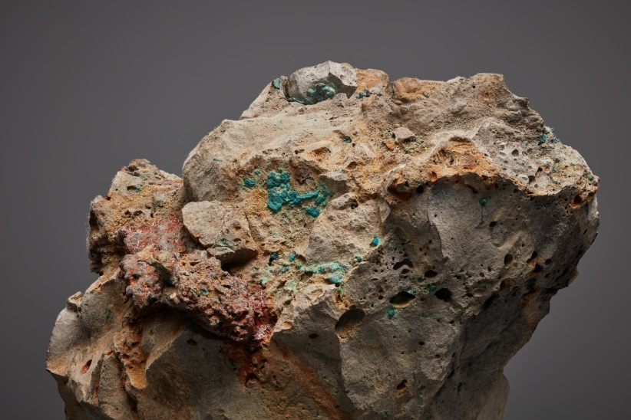
- 柯艾桑南，《橡膠人》，2014-2015。三頻道彩色錄像裝置、有聲、4分鐘循環播放。Jeu de Paume、CAPA、FNAGP共同製作。影像由藝術家提供。  KHVAY Samnang, Rubber Man, 2014-2015. Digital Still from There-Channel Video Installation, Color, Sound, 4mins Looped. Coproducers by Jeu de Paume, CAPA, FNAGP. Courtesy of the artist. | 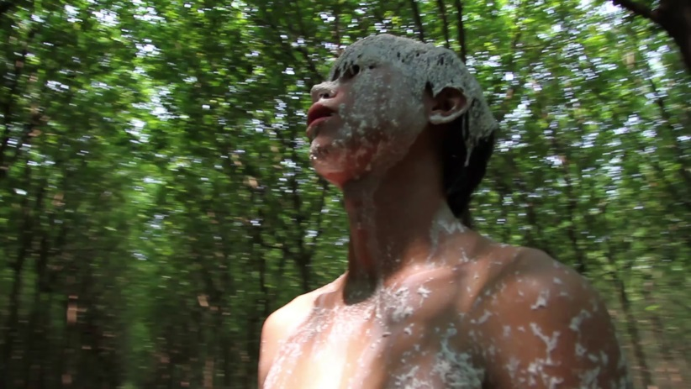
- 林從欣，《字花》，2018。複合媒材裝置。藝術家攝於美國加州漢默美術館展覽「MADE IN L.A. 2018」，影像由藝術家提供。  Candice LIN, La Charada China , 2018. Installation. Photo: Candice LIN, at MADE IN L.A. 2018, HAMMER MUSEUM, L.A. Courtesy of the artist. | 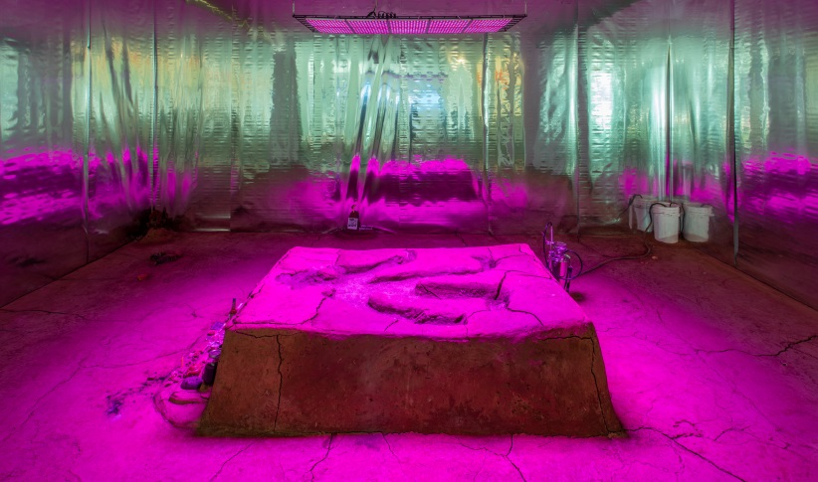
- 尼古拉斯．曼甘，《白蟻經濟》，2018。石膏、泥土3D列印、高分子塗料、塑合木板、有色軟鋼、日光燈、四組Sony Trinitron PVM 9042QM螢幕、循環播放錄像檔案、四頻道環繞音響播放白蟻示警聲響。影像由藝術家與澳洲墨爾本薩頓畫廊提供。  Nicholas MANGAN, Termite Economies, 2018. 3D printed plaster, dirt, synthetic polymer paint, plywood, painted mild steel, fluorescent bay lights, 4 Sony Trinitron PVM 9042QM monitors, archival and recorded footage (continuous loop), four channel surroundsound of termite warning signals. Variable dimensions. Courtesy of the artist and Sutton Gallery, Melbourne; Hopkinson Mossman, Auckland; and LABOR, Mexico City, D.F. | 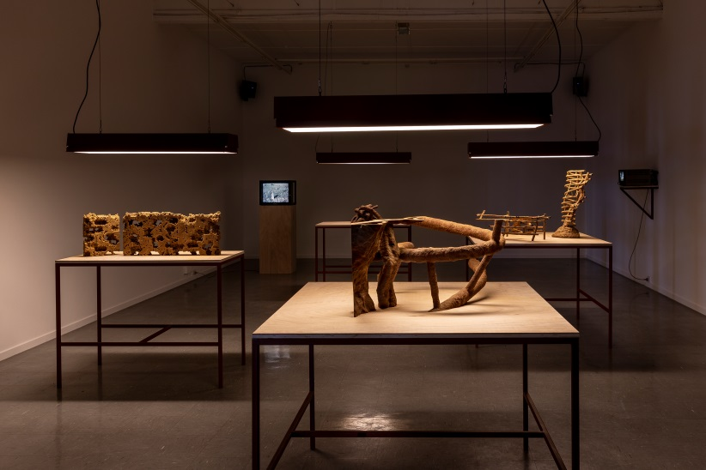
- 茱瑪納．曼娜，〈花瓶、花綵與字典〉，2016 （選自《後植物標本館》，2016）。複合媒材裝置。©影像為藝術家所有；賽門．佛格攝於德國柯隆藝術協會展覽「ars viva 2017」。  Jumana MANNA, Vase with Festoon of Flowers and Dictionary, 2016 (from Post Herbarium, 2016). Installation. © Jumana MANNA. Photo: Simon Vogel, at ars viva 2017, Kölnischer Kunstverein, Cologne. Courtesy of the artist. | 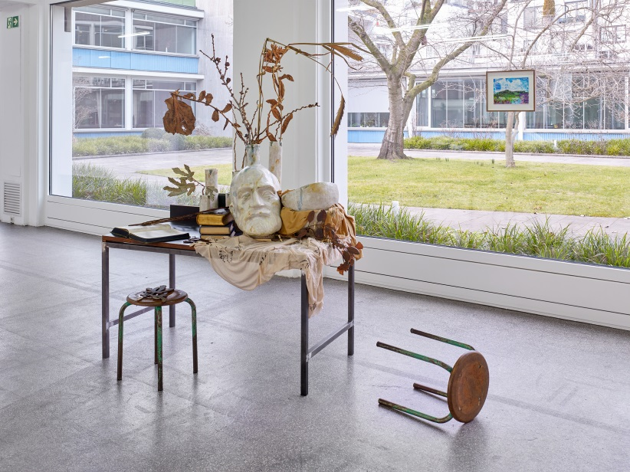
- 吳明益，《人如何學會語言》，2018。彩色插畫。影像由藝術家提供。  WU Ming-Yi, How the Brain got Language?, 2018. Color Illustration. Courtesy of the artist. | 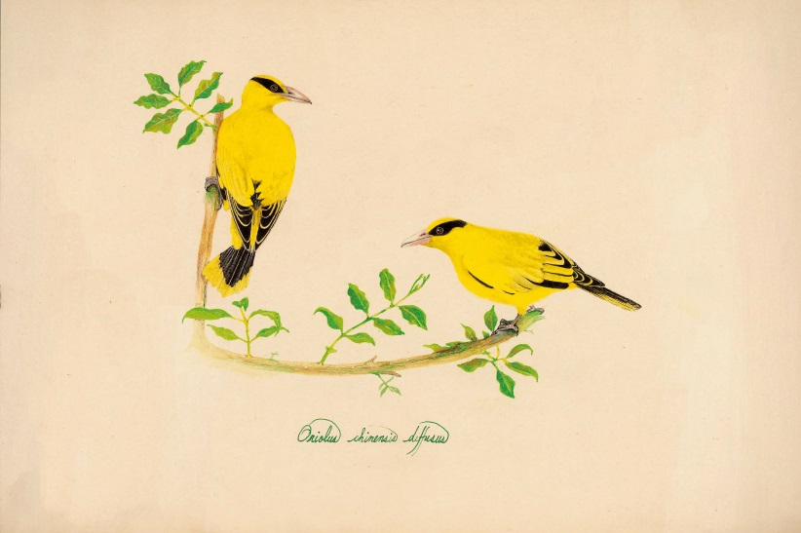
- 鄭波，《蕨戀2》，2018。單頻道錄像，4K彩色、有聲，20分鐘。影像由藝術家提供。  ZHENG Bo, Pteridophilia 2, 2018. Single Channel Video, 4K Color Sound, 20mins. ZHENG Bo. Courtesy of the artist. | 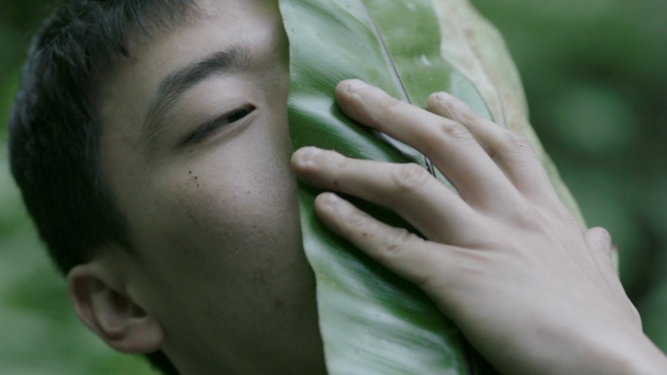
- 柯金源，《1993臺北八里海岸嚴重侵蝕，碉堡地標變遷》，1993。攝影。影像由藝術家提供。  KE Chin-Yuan, 1993 Sever Coastal Erosion Causing the Collapse of a Seaside Fortress at Bali Coast, Taipei, 1993. Photograph. Courtesy of the artist. | 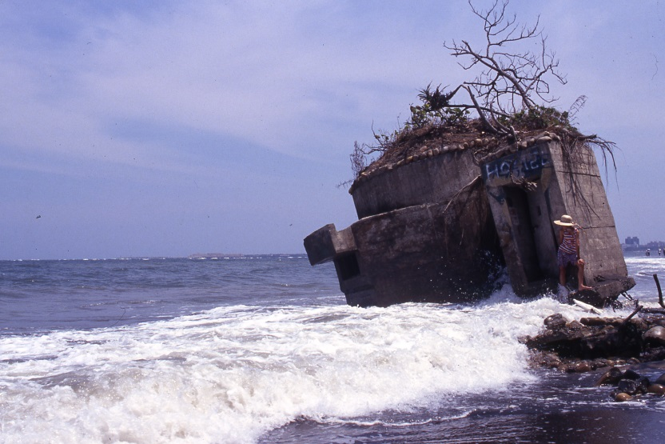
- 黃信堯，《印樣白冷圳》，2018。單頻道錄像。影像由藝術家提供。  HUANG Hsin-Yao, Contact Prints of Pai-leng Canal, 2018. Single channel video. Courtesy of the artist. | 